HowTo-move EC2 Instances in AWS

**Purpose:**

The purpose of this procedure is to provide steps required to move an AWS EC2 instance from one Availability Zone (AZ), Subnet, VPC, AWS Account, or AWS Region to another AZ, Subnet, VPC, AWS Account, or AWS Region in the AWS cloud.

**Prerequisite (s):**

N/A

**Procedure:**

**A.** **Create an AMI from the existing EC2 instance**

 1. Please refer to the following link on how to create AMI from an existing EC2 instance in AWS

<https://docs.aws.amazon.com/toolkit-for-visual-studio/latest/user-guide/tkv-create-ami-from-instance.html>

2. IMPORTANT: Please write down all of the configuration details of the existing instance, i.e., placement group, IAM role, shutdown behavior, Termination protection, Monitoring, Tenancy, storage size, instance type, tags, key pairs, etc. You will need this information later.

3. The new VPC may not have the same security group content.  Be sure to write down the current security group content so you can ensure it is replicated in the new location.

**B. Choose the destination for the new instance**

1. If the new instance will be created within the **same AWS account and region** as the original instance, skip steps **C**and**D,**thencontinue with step **E**and**F**
2. If the new instance will be created within a **different AWS account** but within the **same AWS region**as the original instance, continue with step **C,**then **E**and**F,**skip step **D**
3. If the new instance will be created within a**different AWS region**, continue with step **D**, then **E**and**F,**skip step**C**

**C.** **Share** **AMI with other account**

If the instance is to be moved to a different account within the same region, we need the following additional steps to share the created AMI with the other account.

1. Get the desired account number from the sign in page
2. On AWS console, go to **Services->EC2->AMIs** and choose the AMI created in step **A** above
3. Choose **Actions -> Modify Image Permissions**

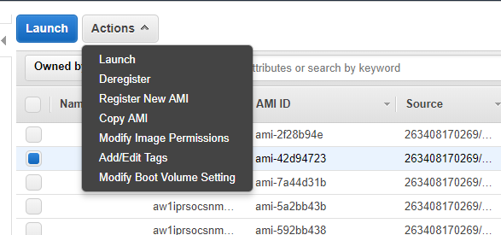

     4. Put the destination account number on the **AWS Account Number**space,and click on

**Add Permission**

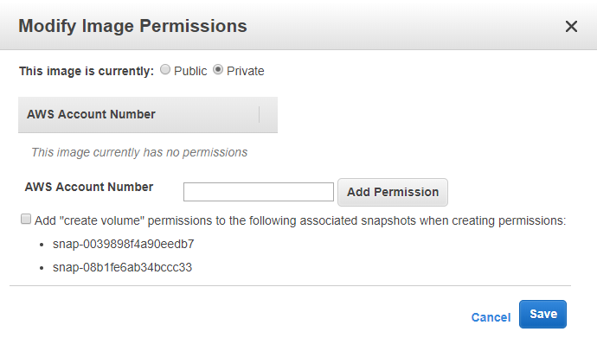

     5. Choose **Save** when you are done

**D.**  **Copy AMI to another region**

To move an instance from one region to another region, we should copy the AMI to the destination region **in addition to** the AMI creation in step **A** above.

1. On the source account, go to **Services->EC2->AMIs**, choose the AMI created in step **A,** then go to **Actions -> Copy AMI**

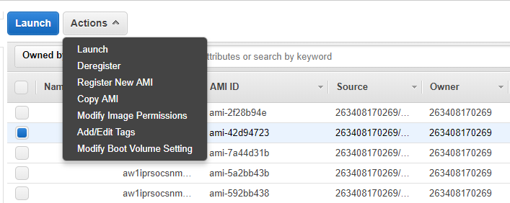

1. Choose the destination region from the dialog box

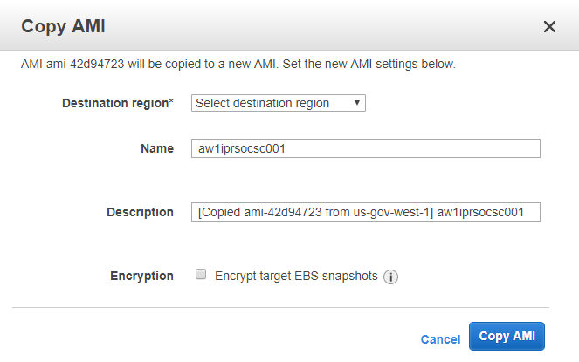

1. Give a name and description for the AMI so that it can be easily identified on the destination region
2. Switch to the destination region - click on the region menu on the top right part of the AWS Console, next to the account name

  5. Check if the copied AMI is available in the AMI list of the new region; click on **Services->EC2->Instances->Launch Instance->My AMIs->Shared with me**

**E.**  **Launch** **new instance using the new AMI**

1. On AWS console, go to **Services->EC2->Instances->Launch Instance**
2. Choose the newly created AMI from **My AMIs -> Shared with me**
3. Choose the same instance type as the existing instance (refer to notes from Step **A** above)
4. Choose the VPC or Subnet for the new instance
5. Make sure all other parameters are similar to the existing instance, such as Placement group, IAM role, Shutdown behavior, Termination protection, Monitoring, Tenancy, etc (refer to notes from Step **A**)
6. Add appropriate tags for the new instance (refer to notes from Step **A**)
7. Choose Security groups, based on VPC, account, or region (refer to notes from Step **A**)
8. Choose an existing key-pair or create a new key-pair for the new instance
9. Check if the instance is created - on AWS console, go to **Services->EC2->Instances**, and search by using the instance name that was used in the tag

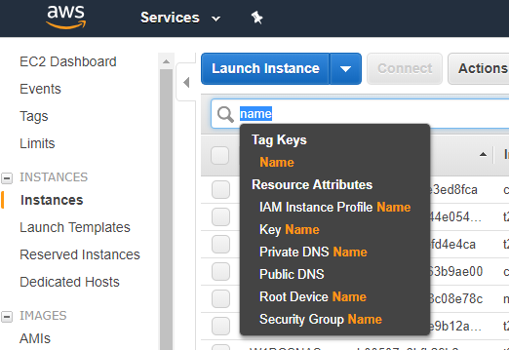

10. Make sure the instance is accessible via ssh (Linux)

11. Check if the data on the new instance is consistent with the existing instance

12. Make sure all post provisioning requirements, such as joining to domain, registering to Katello, bootstrapping to chef, installing security tools, and so on is performed

**F. Cleanup**

After the new instance is provisioned using the image taken from the existing instance, we should do some cleanup tasks to complete the process

First, communicate with individuals who have requested the task, if this is done for another team member with a JIRA ticket

1. If the new instance has been provisioned in a **different region**, then deregister the AMI in the destination region

* Go to **Services->EC2-AMIs**
* choose the copied AMI from the list
* Go to **Actions->Deregister**

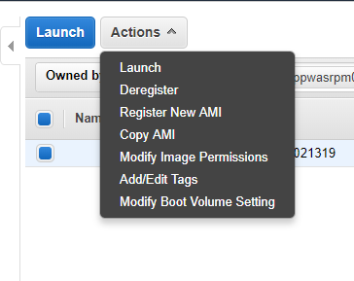

2. If the new instance has been provisioned in a **different account**, then remove the shared account from the source account

* Go to **Services->EC2-AMIs**, choose the shared AMI
* Go to **Actions->Modify Image Permission**
* Remove the account shown below "**AWS Account Number**", then deregister the AMI

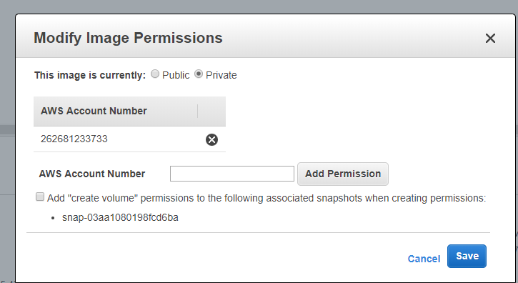

3. If the new instance has been provisioned on the same account and region, then deregister the AMI

* Go to **Services->EC2-AMIs**, choose the newly created AMI
* **Actions->Deregister**

1. Finally, terminate the source instance

**Note: Step E above assumes provisioning of the new instance using AWS Console. However, with all the acquired information above, a Terraform file can be also created and used to provide the new instance using Terraform.**

**Result or Final State:**

Following the above procedure properly, a new instance can be created in the desired AZ, Subnet, VPC, AWS Account, or AWS Region using the AMI from an existing instance.